**Splunk Log Drainer & Log Analysis**

**Accessing the application:**

PCF App URL : [http://**cir-revamp-qa**.devaoa.inbcu.com/dist/index.html](http://cir-revamp-qa.devaoa.inbcu.com/dist/index.html)

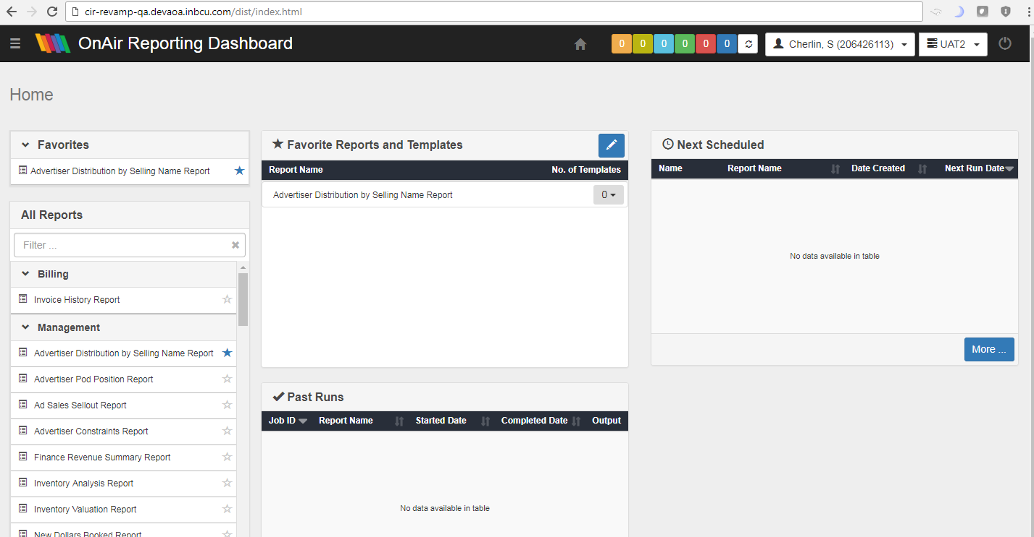

Application log is drain into the splunk instance at real time

Splunk URL: <http://splunkenterprise.inbcu.com>

**Splunk Dashboard**:

Note we are able to see the application log in real time in splunk dashboard ,we can do analysis with the help of splunk QL and also we can create alert on application failure or any JVM issue.

Sample Query for analysis

**Search Query**: index = app_pcf_dev_aoa_applogs_index cf_space_name="Software-Eng-Programmatic-qa" cf_app_name="cir-revamp-qa"

